* Use the Excel file Named: **Retail Analysis** as a data source.



* Format the data in Excel Tables by give each table a unique name (**Buyers, Dates, Managers, Regions, and Sales)**
* In Powerbi from Get Data- Excel Workbook-browse to the excel file
* Choose the Tables: **Buyers, Dates, Managers, Regions, and Sales.**
* Import tables to power query through Transform Button
* Explore the power Query Editor Window, the Queries, Properties, and Applied Steps.
* Check and confirm the data type for each column
* From View Menu Choose Column Quality Check Box
* From the Small table icon on the left of the **Sales** Query, choose **remove top rows and type 5**
* From View Menu Choose Column Profile Check Box to explore the data distribution in each column.
* **Data Transformation:** 
  + **Sales Table:** 
    - In the category Column: Extract Text after delimiter, Delimiter is –
    - Repeat the same for the Buyers table.
  + **Manager Table:** 
    - Add Conditional Col. to add Mr. or Miss. Based on the gender
    - Name the new column **Title**
    - Select columns: **Title, Manager 1st name, and 2nd name** and click **Merge** Columns, Sequence of choosing the columns is important, Name the new col. **Manager_Full_Name**
  + **Sales Table:** 
    - Add Custom column to the sales table named **Sales**
      * ***Sales=Sales Price* Total Units***
    - Add Custom column to the sales table named **Cost**
      * ***Cost=Cost Price* Total Units***
    - Add Custom column to the sales table named **Gross Profit**
      * ***Gross Profit=Sales – Cost***
    - Change the Data type of the 3 new columns to Decimal numbers
* Close & Apply to load the data in tables in Powerbi Model.
* **Data Modeling:**

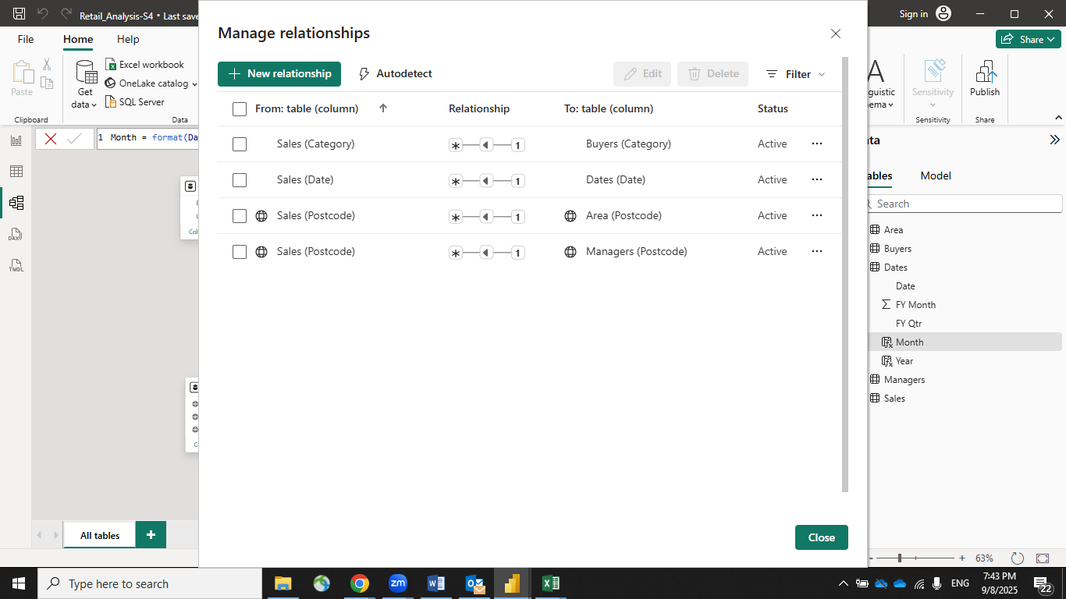

* + **In table view apply some formatting to the Sales table:**
    - **GrossProfit, Sales, Cost** Format with $
    - Postcode field in **Managers** & **Regions** Tables------- Data Category, Postal Code
    - Change the data category of Area to place and state to state
* **Visualizations:**
  + **Card Visual**
    - Value: Sales
  + **Clustered column chart (to show sales margin by quarter)**
    - X axis: FY Qtr.
    - Y Axis: Sales, Gross Profit
    - Change visualization to line and clustered column chart and put the gross profit in the line y axis
    - Put data labels on and remove the Y axis
  + **Clustered column chart (to show sales by state and chain)**
    - X axis: State
    - Y Axis: Sales
    - Legend: Chain
  + **Pie chart (to show sales by chain )**
  + **Map (to show sales by location)**
    - Location: State , Country
    - Bubble size: Sales

Note: if the map not reading the location correctly, in table view, in regions table we will add a column to define the country:

***State, Country = Regions[State]&", USA"***

And Change data category to state or province or Place.

* + **Bar Chart (to show sales by category and chain)**
    - X Axis :Sales
    - Y Axis : Category
    - Legend: Chain

Create New Explicit Measure Gross profit %

Total Sales = sum(Sales[Sales])

Total Gross Profit = sum(Sales[Gross Profit])

Gross Profit % = DIVIDE([Total Gross Profit],[Total Sales],0)

* + **Bubble chart (to show Sales , gross profit by category across time)**
    - X Axis: Sales
    - Y Axis: Gross Profit %
    - Legend: Category
    - Size: Gross profit %
    - Play Axis: FY Qtr.

* + **Slicer to filter by state** 
    - Explore select settings on the slicer.
  + **Rename the current sheet with Summary**
  + **Create another sheet with name Regions & Chain**
  + **Clustered bar chart (to show Sales by Buyer )**
  + **Map ( to show Sales and chain and post code )**
    - **Location: PostCode**
    - **Legend: Chain**
    - **Bubble size: Sale**

Note: if the map not reading the location correctly, in table view, in regions table we will add a column to define the place:

***PostCode, Area, Country = Regions [Postcode]&" ,"&Regions[Area]&" , USA"***

* + **Clustered bar chart (to show Sales by gross profit by state and manager) use arrows**
    - Y Axis : State & Manager
    - X Axis : Sales
    - Tool tips : GP%
  + **Area chart (to show sales over time for the different chains)**
    - X Axis : FY Qtr
    - Y Axis : Sales
    - Legend : Chain
  + **Clustered column chart (to show sales by state and chain)**
    - X Axis: State
    - Y Axis: Sales
    - Legend: Chain
  + **Slicer by chain**
  + **Multi row card to show sales, gross profit and GP %**
  + **Slicer by state**
* Format the colors based on your organization theme, add your organization name and logo, and save the file with name retail_analysis.pbix.
* Enable Drill Trough option in the **Regions & Chains** sheet
* From View , Show the Bookmark pane
* Add Bookmarks for different views
* In the source file, Add the August 24 Data to the sales table and Refresh from Powerbi and notice the difference in numbers.

